Course-Level Learning Objectives

Overview
Course-level learning objectives (CLO) are essential elements of course creation. They outline your vision of what learners will know and be able to do by the end of the course. Everything in your course (all module-level objectives (MLOs), learning activities, and course content of any kind) should support and be aligned with one or more of the CLOs. Review Course Alignment for more information about aligning CLOs and MLOs at the Mays Flex Online Knowledge Base.
This guide provides guidelines for creating measurable learning objectives. It includes the following sections:
- Developing Measurable Objectives
- Applying Bloom’s Taxonomy
  - Blooms in Action
  - Bloom's Levels for Graduate Adult Professional Learners

Developing Measurable Objectives
Each CLO states something that learners will be able to do after taking the course, which shows mastery of the course content. CLOs must be observable and measurable by the instructor within the course. For example, a learning objective that states “upon completion of this course, learners will be able to manage an enterprise-wide supply chain initiative.” is not measurable within the context of the course because the instructor has no way of observing it.
All course assignments should be used to measure and assess how well a learner has mastered a concept or process. Follow the three steps below to create a measurable CLO:
- Step 1: Vision – Brainstorm what you want learners to be able to do after taking the course.
- Step 2: Measurement – Determine how you can measure whether, and how much, learners fulfill your vision.
- Step 3: Formula – Write out the learning objective using the formula (see Figure 1).
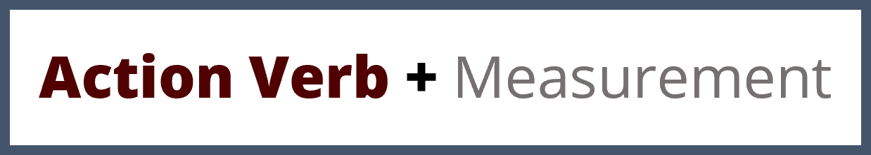
Figure 1. Formula for Learning Objectives

Applying Bloom’s Taxonomy
Bloom’s Taxonomy is a helpful reference as you create your learning objectives. It is educational psychologist Dr. Benjamin Bloom’s categorization of different kinds of thinking skills associated with related action verbs and sorted in ascending order. Instructional designers often use the revision of Bloom’s Taxonomy by Dr. Lorin Anderson, one of Bloom’s students. Bloom’s Taxonomy is frequently illustrated by a pyramid and an associated list of action verbs. Figure 2 demonstrates how the levels of Bloom’s Taxonomy are sequenced.
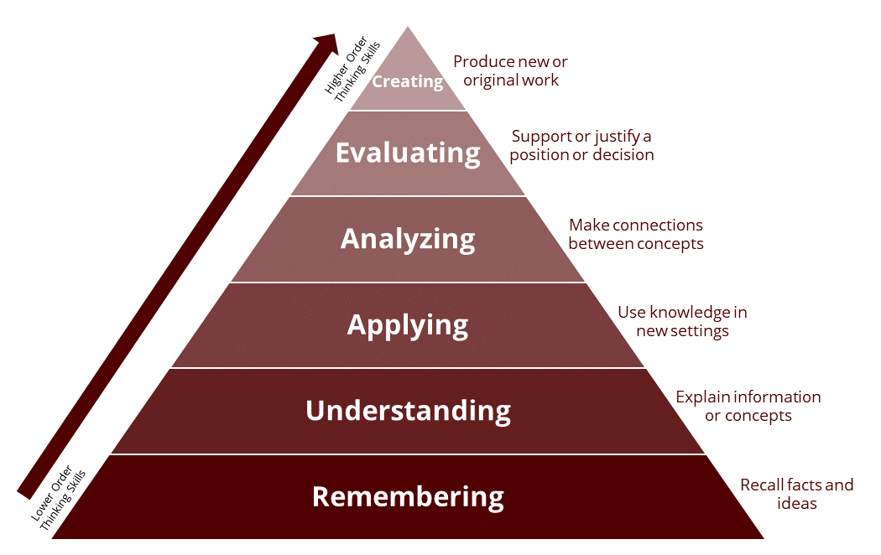
Figure 2: Bloom's Taxonomy Pyramid

Blooms in Action
You should have at least 3 and no more than 6 course-level learning objectives. Each objective should begin with an action verb that allows you to measure learner mastery of the content. It may help to write objectives using this format: “Learners will be able to [insert action verb here] by [insert criteria here].” Note that when writing a list of learning objectives, you do not need to repeat "Learners will be able to" for each one, stating it once as the stem and beginning each objective with the action verb is sufficient, as shown below.
Learners will be able to:
- analyze a work of art and expound on its context and influence by completing a research paper.
- create a simple traffic management system by using a C++ compiler that the instructor can appropriately use.
- appraise the value of investing in a publicly traded company by analyzing financial statements and delivering a presentation defending their conclusions.

Bloom's Levels for Graduate Adult Professional Learners
For a graduate course serving working professionals, course-level objectives should begin at Level 3 (Apply) and reach upward into Levels 4–6 (Analyze, Evaluate, Create), rather than the first two levels (Remember and Understand) (Pappas, 2026). Adult professional learners arrive with substantial experience and foundational knowledge, so objectives built on recall and basic comprehension undervalue what they already bring and rarely reflect the work they do (Knowles et al., 2020). Graduate-level study is meant to develop judgment, problem-solving, and the ability to generate new solutions in complex, real-world contexts, outcomes that live in the higher levels of the taxonomy (Merriam & Baumgartner, 2020). Lower-order cognitive skills is not ignored; it is assumed and embedded as the necessary foundation for application and analysis rather than treated as a standalone objective. Anchoring objectives at Level 3 and above also produces outcomes that are observable and measurable through authentic tasks such as case analyses, projects, and defended recommendations, which aligns with this guide's emphasis on measurable mastery and keeps the course rigorous, relevant, and appropriate to the learners' professional standing.
When selecting action verbs for course learning outcomes, use Bloom's Taxonomy to match the desired level of student mastery. For graduate and professional learners, focus primarily on the higher-order cognitive skills highlighted on the right side of Table 1—Analyze, Evaluate, and Create. The table provides examples of action verbs for each level of the taxonomy.
Lower-order cognitive skills |  | Higher-order cognitive skills:  encouraged for graduate/professional learners
Remember | Understand | Apply | Analyze | Evaluate | Create
Define | Explain | Apply | Analyze | Argue | Assemble
Describe | Classify | Calculate | Breakdown | Assess | Compose
Identify | Convert | Experiment | Compare/contrast | Conclude | Construct
Memorize | Discuss | Illustrate | Criticize | Debate | Create
Order | Estimate | Implement | Deconstruct | Defend | Design
Outline | Give example(s) | Investigate | Deduce | Evaluate | Develop
Recall | Infer | Operate | Diagram | Judge | Formulate
Recognize | Interpret | Perform | Differentiate | Justify | Invent
Reproduce | Predict | Produce | Discriminate | Test | Plan
State | Summarize | Solve | Examine | Verify | Produce
Table 1: Sample Action Verbs by Bloom’s Levels

Resources
To learn more about Bloom’s Taxonomy and how it applies to writing learning objectives, see the following resources:
Bloom’s Taxonomy: Independent chapter review by Mary Forehand.
Applying Bloom’s Taxonomy in eLearning by Ravinder Tulsiani
Bloom’s revised taxonomy explained for instructional designers and educators by Christopher Pappas.

References
- Knowles, M. S., Holton, E. F., III, Swanson, R. A., & Robinson, P. A. (2020). The adult learner: The definitive classic in adult education and human resource development (9th ed.). Routledge.
- Merriam, S. B., & Baumgartner, L. M. (2020). Learning in adulthood: A comprehensive guide (4th ed.). Jossey-Bass.
- Pappas, C. (2026, May 7). Bloom’s revised taxonomy explained for instructional designers and educators.

